**REVERING OF DIGITS OF INTEGER:**

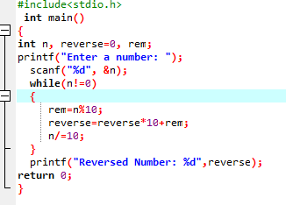

**OUTPUT**

